1. Write a Selenium script using Python to navigate to a Google (https://www.google.com) and search "Selenium Testing".

from selenium import webdriver

from selenium.webdriver.common.keys import Keys

import time

driver = webdriver.Chrome()

driver.get("https://www.google.com")

driver.find_element('id',"APjFqb").send_keys("Selenium Testing")

time.sleep(2)

driver.find_element('id',"APjFqb").send_keys(Keys.ENTER)

time.sleep(2)

driver.close()

**Output :**

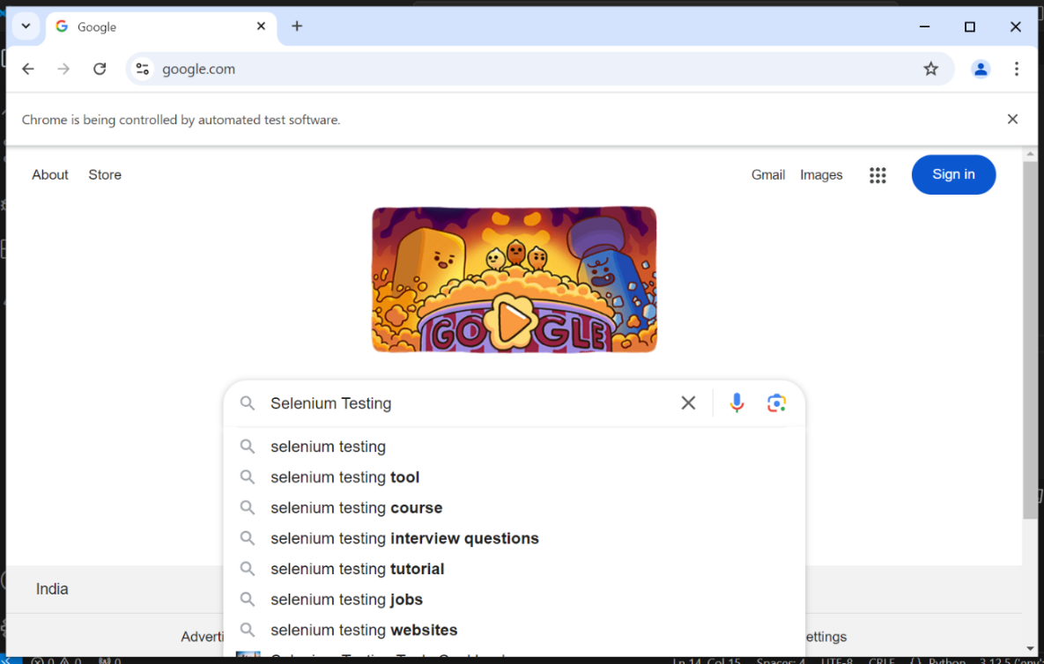

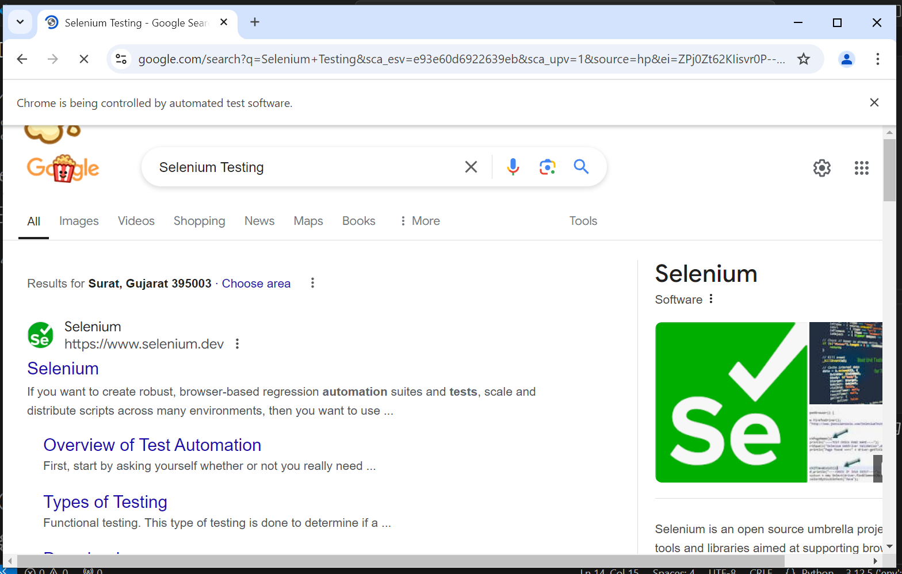

1. Create a Selenium script that scraps table data from "https://iqssdss2020.pythonanywhere.com/tutorial/default/dynamic" and store that data into csv file.

from selenium import webdriver

import time

from selenium.webdriver.common.by import By

driver = webdriver.Chrome()

table_url = "https://iqssdss2020.pythonanywhere.com/tutorial/default/dynamic"

driver.get(table_url)

time.sleep(3)

file = open("scrap_table.csv", "w", encoding="utf-8")

table_body = driver.find_element(By.XPATH, "//*[@id='result']/table/tbody")

entries = table_body.find_elements(By.TAG_NAME, 'tr')

headers = table_body.find_elements(By.TAG_NAME, 'th')

table_header = ''

for i in range(len(headers)):

    header = headers[i].text

    if i == len(headers) - 1:

        table_header = table_header + header + "\n"

    else:

        table_header = table_header + header + ","

file.write(table_header)

for i in range(1, len(entries)):

    cols = entries[i].find_elements(By.TAG_NAME, "td")

    table_row = ""

    for j in range(len(cols)):

        col = cols[j].text

        if j == len(cols) - 1:

            table_row = table_row + col + "\n"

        else:

            table_row = table_row + col + ","

    file.write(table_row)

driver.close()

file.close()

**Output :**

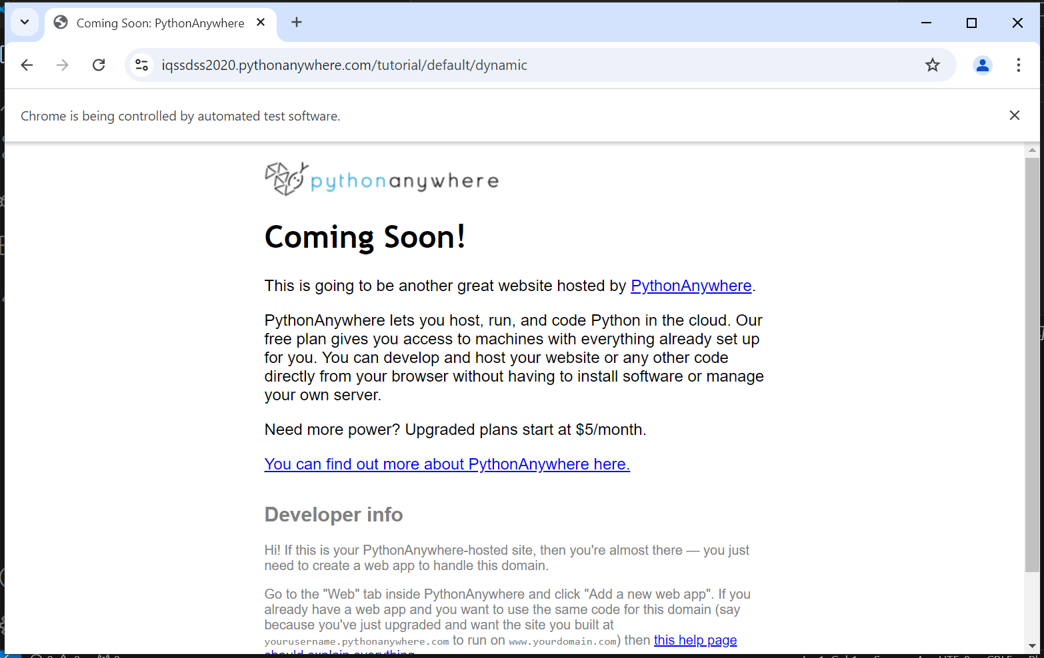

1. Create a Selenium script to upload the Image (http://autopract.com/selenium/upload1/).

from selenium import webdriver

from selenium.webdriver.common.by import By

import time

driver = webdriver.Chrome()

driver.maximize_window()

driver.get("http://autopract.com/selenium/upload1/")

file_input = driver.find_element(By.NAME, "files[]")

file_path = "E:/SDJIC/Work/ATF/jenilmywp.png"

file_input.send_keys(file_path)

time.sleep(2)

driver.find_element(By.CLASS_NAME, "start").click()

time.sleep(3)

print(driver.find_element(By.CLASS_NAME, "name").text)

time.sleep(10)

driver.close()

**Output :**

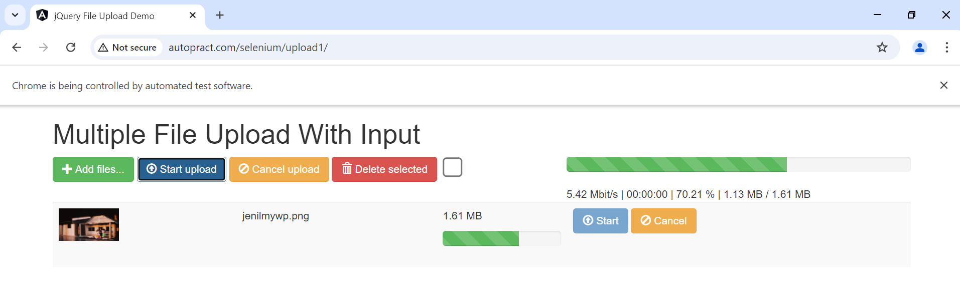

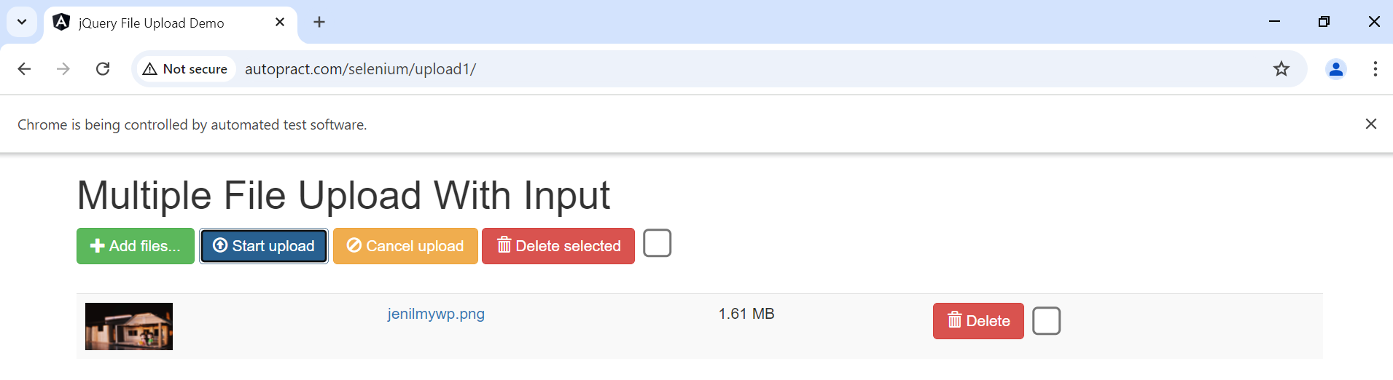

1. Create a Selenium script that scraps Web Developer Job details data from Indeed website and store that data into csv file.

from selenium import webdriver

from selenium.webdriver.common.keys import Keys

from selenium.webdriver.common.by import By

def indeed_job_search():

    browser = webdriver.Chrome()

    browser.get("https://in.indeed.com/")

    browser.implicitly_wait(2)

    search_bar = browser.find_element("id", "text-input-what")

    search_bar.send_keys('Web Developer')

    search_bar.send_keys(Keys.RETURN)

    browser.implicitly_wait(2)

    search_results = browser.find_elements(By.XPATH,'//h2/a')

    file = open("indeed_job_search.csv", 'a')

    file.write("\n")

    for job_element in search_results:

        job_title = job_element.text

        job_link = job_element.get_attribute('herf')

        file.write("%s | link: %s \n" %(job_title, job_link))

    browser.close()

if __name__ == "__main__":

    indeed_job_search()

**Output :**

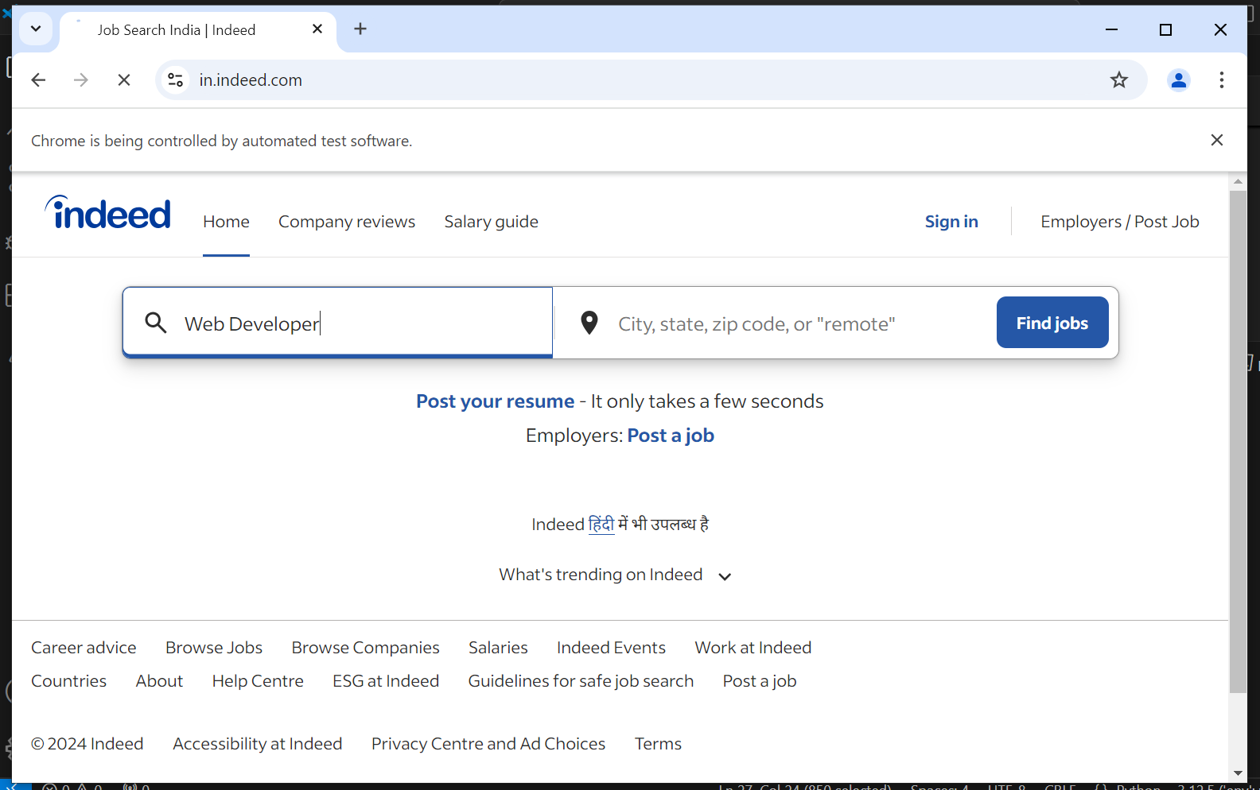

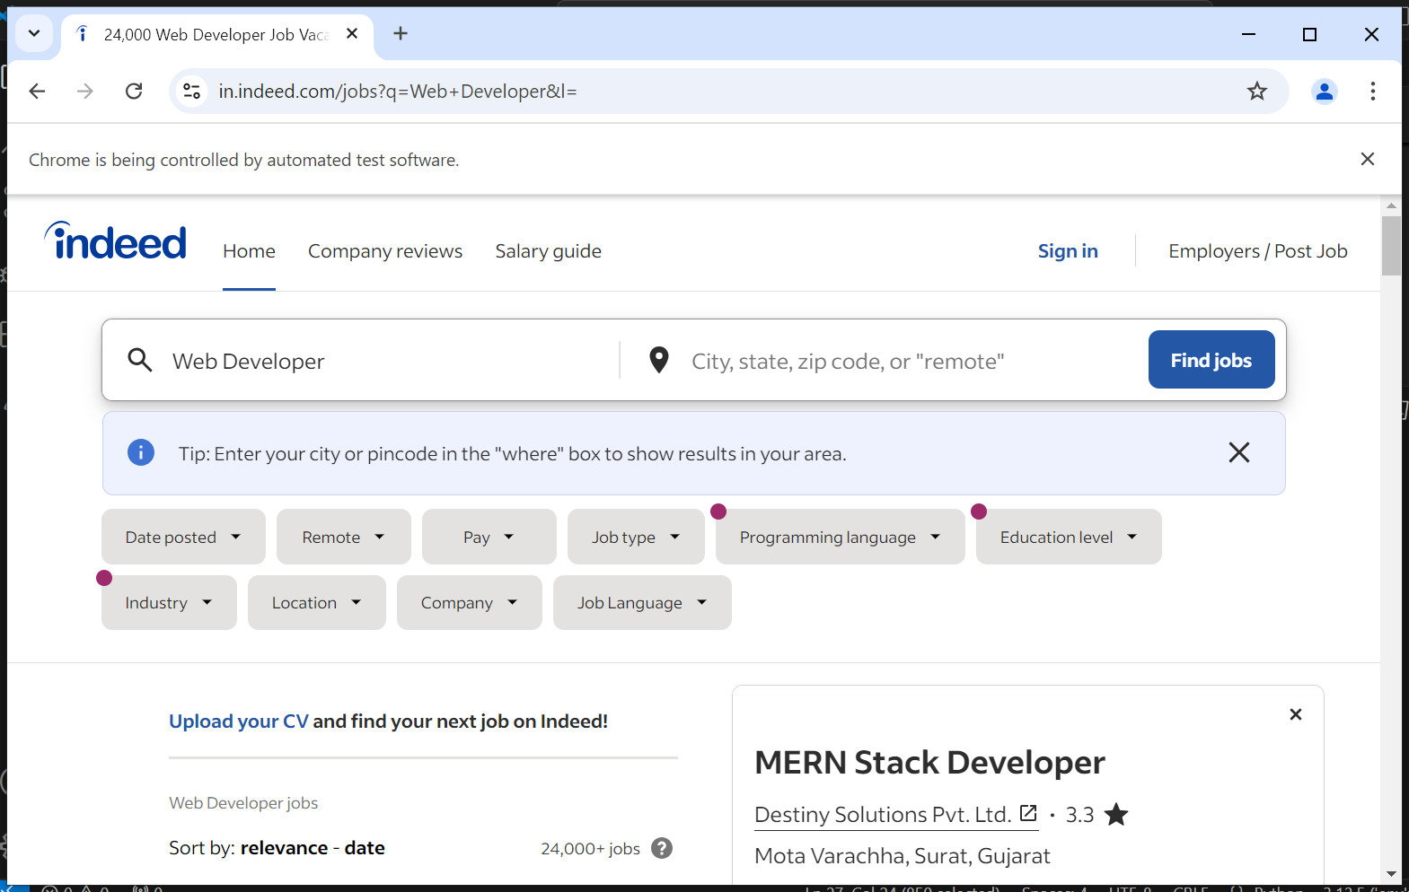

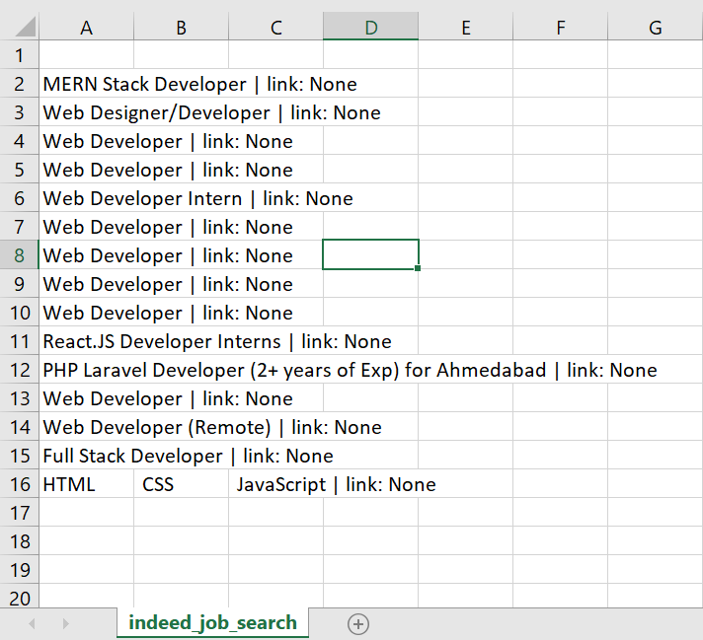

1. Write a Selenium script that scraps text from https://www.federalregister.gov/documents/2013/09/24/2013-21228/affirmative-action-andnondiscrimination-obligations-of-contractors-and-subcontractors-regarding.

from selenium import webdriver

import time

from selenium.webdriver.common.by import By

driver = webdriver.Chrome()

journalAddress = "https://www.federalregister.gov/documents/2013/09/24/2013-21228/affirmative-action-and-nondiscrimination-obligations-of-contractors-and-subcontractors-regarding"

driver.get(journalAddress)

time.sleep(3)

articleObjects = driver.find_elements(By.XPATH, '//div[@id="fulltext_content_area"]/*')

articleDictionary = dict()

myKey = ""

myValue_total = ""

for i in range(len(articleObjects)):

    tagName = articleObjects[i].tag_name

    if tagName.startswith("h"):

        if myKey:

            articleDictionary[myKey] = myValue_total

            myKey = ""

            myValue_total = ""

        myKey = articleObjects[i].get_attribute("innerText")

    if tagName.startswith("p"):

        myValue = articleObjects[i].get_attribute("innerText")

        myValue_total = myValue_total + myValue

    if tagName.startswith("ul"):

        myBullets = articleObjects[i].find_elements(By.XPATH, 'li')

        for j in range(len(myBullets)):

            myBullet = myBullets[j].get_attribute("innerText")

            myValue_total = myValue_total + myBullet

driver.close()

article = ""

for key, value in articleDictionary.items():

    article = article + key + '\n\n' + value + "\n\n*******************\n\n"

print(article)

**Output :**

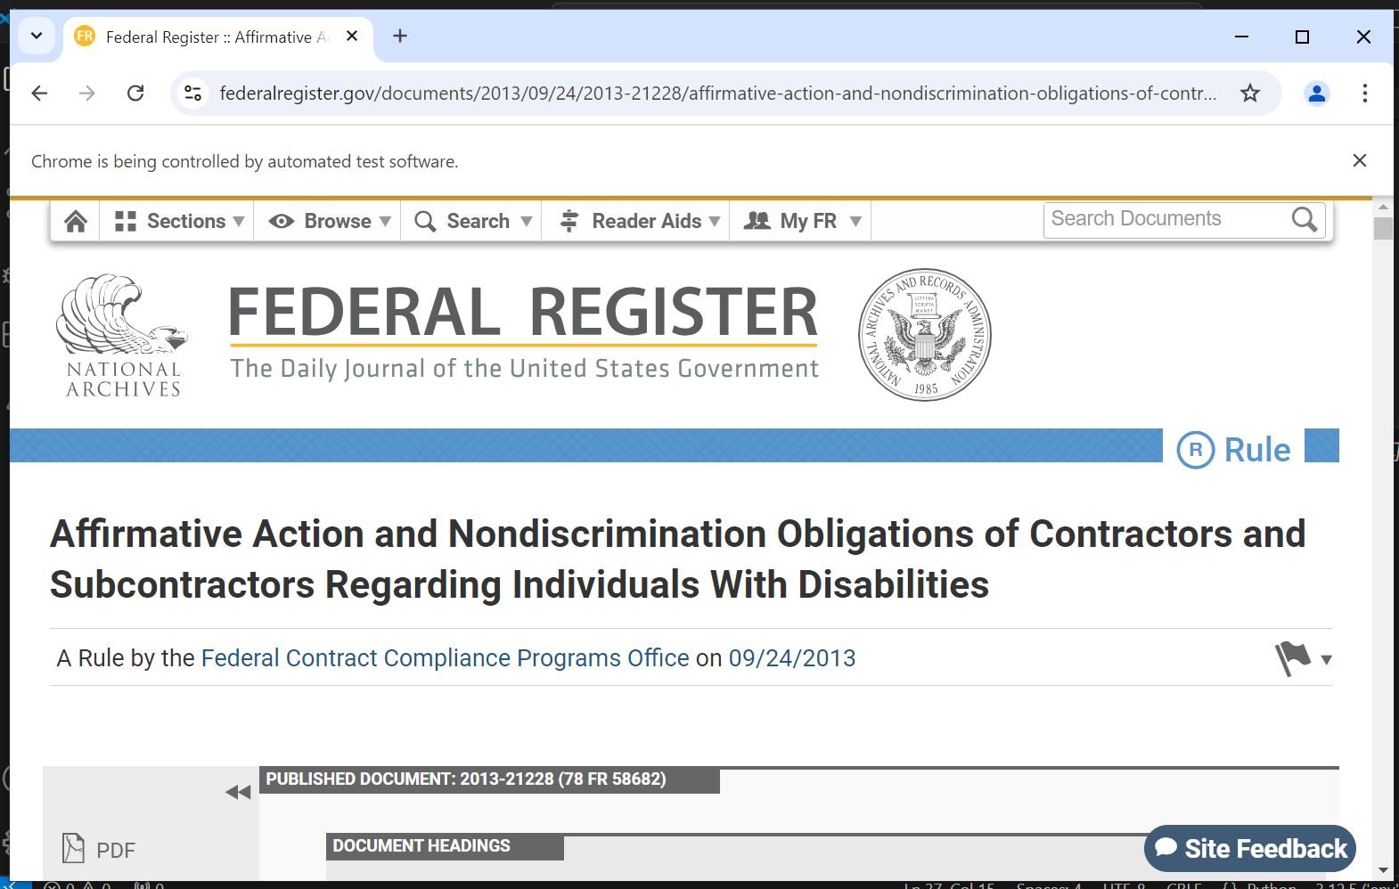

1. Implement an Explicit Wait in a Selenium script. Choose a scenario, such as waiting for an element to be clickable, and create a script that demonstrates the proper usage of explicit waits to improve test stability.

from selenium import webdriver

from selenium.webdriver.common.by import By

from selenium.webdriver.support.ui import WebDriverWait

from selenium.webdriver.support import expected_conditions as EC

import time

# Create a new instance of the Chrome driver

driver = webdriver.Chrome()

# Navigate to the URL

driver.get("https://www.federalregister.gov/documents/2013/09/24/2013-21228/affirmative-action-andnondiscrimination-obligations-of-contractors-and-subcontractors-regarding")

# Wait for the "Search" button to be clickable

search_button = WebDriverWait(driver, 10).until(

    EC.element_to_be_clickable((By.ID, "search-button"))

)

# Click the "Search" button

search_button.click()

# Wait for the search results to be loaded

search_results = WebDriverWait(driver, 10).until(

    EC.presence_of_all_elements_located((By.CSS_SELECTOR, ".search-result"))

)

# Print the number of search results

print(f"Found {len(search_results)} search results")

# Close the browser

driver.quit()

**Output :**

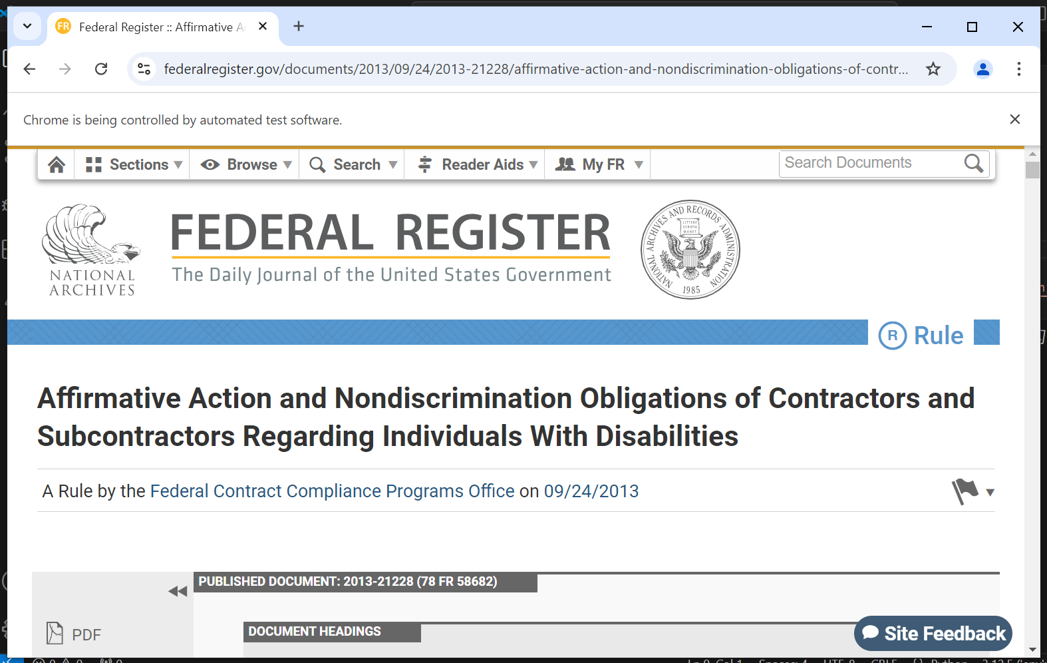

1. Create a Selenium Script for Automating Input form and submit the form. (https://www.lambdatest.com/selenium-playground/input-form-demo).

from selenium import webdriver

from selenium.webdriver.common.by import By

from selenium.webdriver.support.ui import Select

import time

driver = webdriver.Chrome()

driver.get("https://www.lambdatest.com/selenium-playground/input-form-demo")

# print(driver.title)

driver.find_element('id',"name").send_keys("Jenil Ambawala")

time.sleep(1)

driver.find_element('id',"inputEmail4").send_keys("testingjenil@gmail.com")

time.sleep(1)

driver.find_element('id',"inputPassword4").send_keys("Journal@Jenil")

time.sleep(1)

driver.find_element('id',"company").send_keys("JenTech IT Solutions PVT Ltd")

time.sleep(1)

driver.find_element('id',"websitename").send_keys("https://jenilambawala.github.io/MyResume/")

time.sleep(1)

# Select Country

lambdatest = Select(driver.find_element(By.NAME, "country"))

lambdatest.select_by_visible_text("India")

time.sleep(1)

driver.find_element('id',"inputCity").send_keys("Surat")

time.sleep(1)

driver.find_element('id',"inputAddress1").send_keys("Opp Nayara Petrol Pump, Singanpore, Road,")

time.sleep(1)

driver.find_element('id',"inputAddress2").send_keys("Katargam, Surat, Gujarat 395004")

time.sleep(1)

driver.find_element('id',"inputState").send_keys("Gujarat")

time.sleep(1)

driver.find_element('id',"inputZip").send_keys("395004")

time.sleep(5)

# Submit Button

driver.find_element(By.CLASS_NAME, "selenium_btn").click()

time.sleep(10)

driver.close()

**Output :**

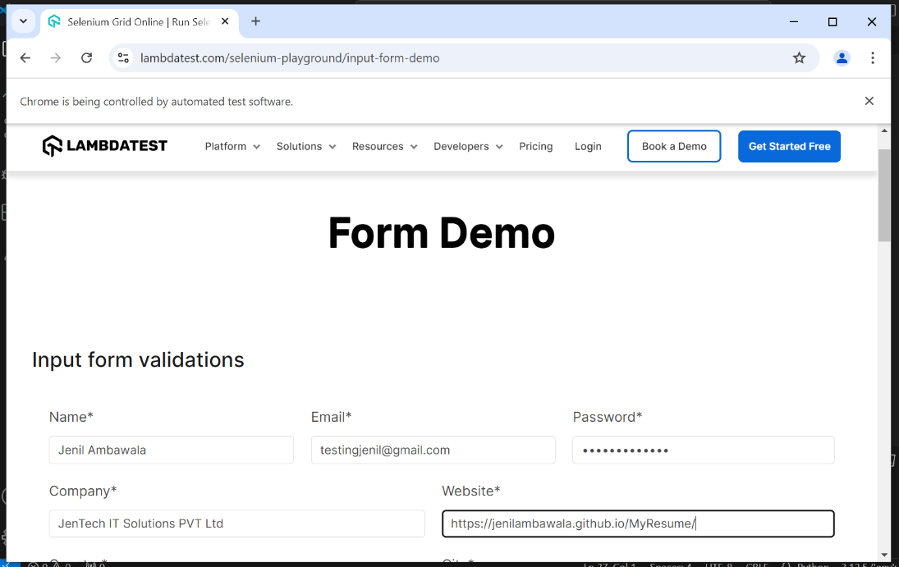

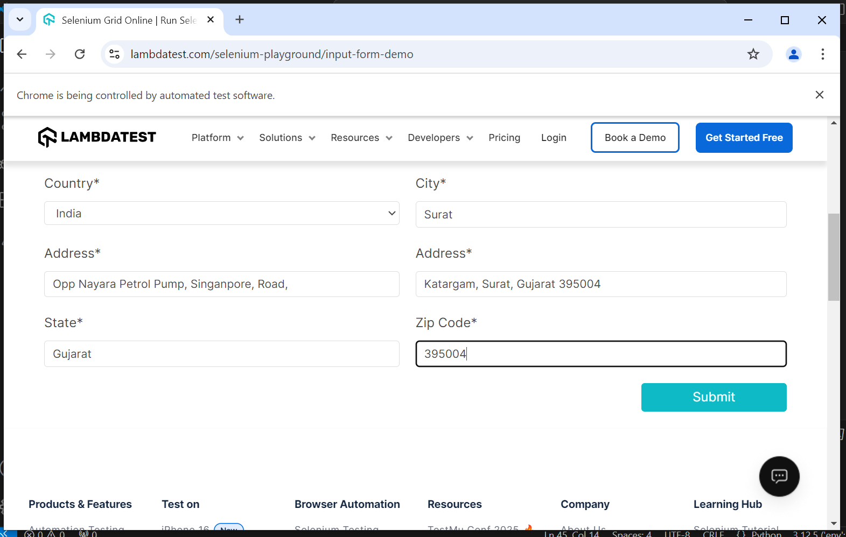

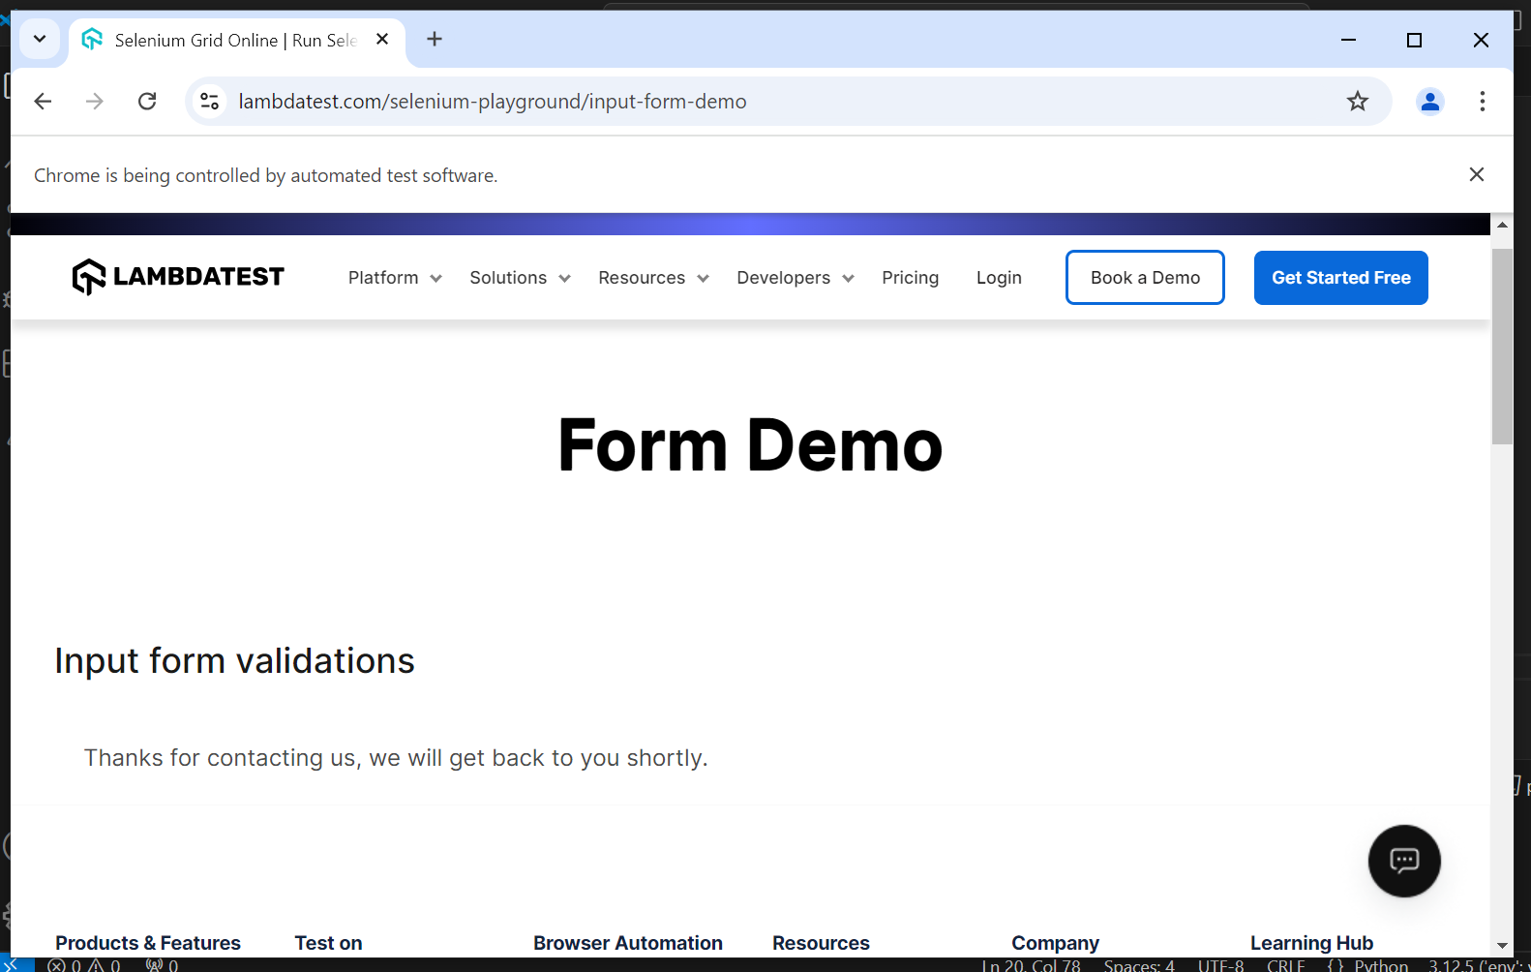

1. Create a Selenium script that automates the form inputs and submit it. (https://www.softwaretestingmaterial.com/sample-webpage-to-automate/).

import time

from selenium import webdriver

from selenium.webdriver.common.by import By

from selenium.webdriver.support.ui import Select

from selenium.webdriver.support.ui import WebDriverWait

from selenium.webdriver.support import expected_conditions as EC

driver = webdriver.Chrome()

driver.get("https://www.softwaretestingmaterial.com/sample-webpage-to-automate/")

# Sample Web Page To Test

driver.find_element('name', "username").send_keys("Jenil Ambawala")

time.sleep(1)

driver.switch_to.default_content()

driver.find_element('name', "password").send_keys("Journal@Jenil")

time.sleep(1)

driver.find_element('name', "comments").send_keys("Jenil Ambawala Automation Testing")

time.sleep(1)

# Checkbox

driver.find_element(By.XPATH, "//input[@value='cbselenium']").click()

time.sleep(1)

# Radio Button

driver.find_element('name', "radioselenium").click()

time.sleep(1)

# Multiple Select Values

hobbies = Select(driver.find_element(By.NAME, "multipleselect[]"))

hobbies.select_by_visible_text("Selenium")

hobbies.select_by_visible_text("Performance Testing")

# Dropdown

lambdatest = Select(driver.find_element(By.NAME, "dropdown"))

lambdatest.select_by_value('ddselenium')

time.sleep(2)

# Date Picker

driver.find_element(By.NAME, 'bday').send_keys("10-11-2002")

time.sleep(3)

# Upload File

file_input = driver.find_element(By.NAME, "filename")

file_path = "E:/SDJIC/Work/ATF/jenilmywp.png "

file_input.send_keys(file_path)

time.sleep(3)

# Download FIle

driver.find_element(By.LINK_TEXT, "Download CSV File").click()

time.sleep(3)

# Select Table

WebDriverWait(driver, 10).until(EC.visibility_of_element_located((By.CLASS_NAME, 'spTable')))

employee_name = "Employee 2"

rows = driver.find_elements(By.XPATH, "//table[@class='spTable']//tr[@class='spTableTr']")

for row in rows:

    # Check if the row contains the employee name

    if employee_name in row.text:

        # Locate the radio button in the same row and click it

        radio_button = row.find_element(By.XPATH, ".//input[@type='radio']")

        radio_button.click()

time.sleep(3)

# Button Click

driver.find_element('name', "spbutton").click()

time.sleep(3)

# Leave a Reply Form

# textarea => comment

driver.find_element('id', "comment").send_keys("Jenil Ambawala is on 2 days Leave from Personal Reason.")

time.sleep(1)

# Name

driver.find_element('id', "author").send_keys("Jenil Ambawala")

time.sleep(1)

# Mail

driver.find_element('id', "email").send_keys("testing.jenil@gmail.com")

time.sleep(1)

# Website

driver.find_element('id', "url").send_keys("https://jenilambawala.github.io/MyResume/")

time.sleep(1)

# Submit

driver.find_element('id', "submit").click()

time.sleep(10)

driver.close()

**Output :**

